**Presentation Notes:**

1. What are the four functions of a computer program listed on the lesson slide?
   1. A computer program controls the hardware of a computer system
   2. It decides how input devices affect output devices
   3. Different programs change the functions of the computer hardware
   4. Computer programs can control more than traditional computer systems
2. Provide an example of a computer input that is not listed on the lesson slide.

An example of computer input is a scanner.

1. Provide an example of a computer output that is not listed on the lesson slide.

An example of computer output is a speaker.

1. Provide another example of how a computer input affects a computer output that is not listed on the lesson slide.

How a scanner scans something and it shows up on the computer monitor.

1. Provide an example of how changing the program changes how computer inputs affect computer outputs that is not listed on the lesson slide.

Different computer games use different controls which means different keys on the computer will do different things.

1. What are some examples of devices that are not traditional computers but that make use of computer programs?
   1. Refrigerators
   2. Microwaves
   3. Toys
   4. Toasters
   5. Cars
2. Provide another example of a device that makes use of a computer program that is not listed on the lesson slide.

A device that makes use of a computer is thermostats.

1. What is another term for a computer program?

Computer software

1. What are some ways that computer software is different from computer hardware?

Software uses logic which is easily changed while hardware uses physical devices which are hard to change

1. How are computer programs written?

Computer programs are written using a computer language written in a text editor such as Microsoft word.

1. Why are computer programs composed of many lines of computer code?

Because 1 line of a computer program is a simple statement and most computer programs are very complex which is why they require many commands.

1. List some examples of different computer languages.
   1. C+
   2. Java
   3. SQL
   4. Python
2. List some of the benefits of the Python computer language.
   1. It’s a professional language
   2. Good for prototyping small programs
   3. It is good for beginners
   4. It is the language of choice for 1st year university courses
3. Once you finish this course, how could you answer someone who asks you "Do you know how to program in Java?"

I would answer that I know python which is very similar to java.

1. Could you use Microsoft Word to write a computer program? Explain.

Yes, because it is a text editor but it is not very efficient.

1. What does IDE stand for?

Integrated development environment

1. What are some features of an Integrated Development Environment?
   1. Color coding keywords
   2. Indentation and completion control
   3. Error checking
   4. Runtime support
   5. Bugging
2. What are some factors to consider when choosing an Integrated Development Environment?
   1. How well it supports your language
   2. Is it web based or a download install
   3. Is it as good as other IDE’s
3. What is the name of the IDE that we will be using to create our Python programs?

Repl.it

1. What version of Python will we be using?

Python 3.7.3

1. Draw a sketch of the Repl interface showing the three work areas (panels)

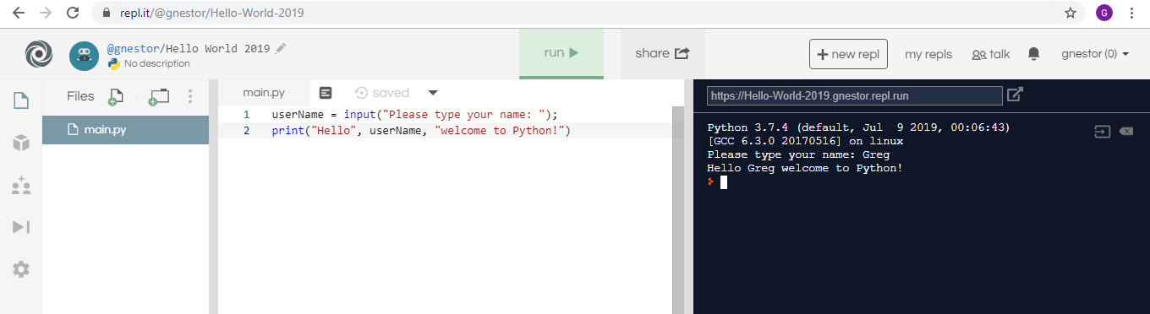

* 1. Label each panel
* At the top there is the name of the program
* On the left is the file under the files tab
* In the middle is where you type the code
* On the right is the program you made
  1. Summarize the function of each panel
* The console shows your program
* The middle panel shows you the code you are typing
* The panel on the left shows you your files and folders

**Student Questions:**

1. Create an account for yourself at www.repl.it
   1. Review the "Terms of Service" to verify that you can legally use this service.
   2. Follow the previous discussed guidelines regarding use of personal information
2. List the part of the "Terms of Service" that verifies that you can legally use this service.

It says they provide users with a hosted environment to practice coding.

1. Explain some of the rights that you give away to Repl.it regarding content you create using their service?

You are not allowed to create inappropriate content and they have the rights to terminate your account without prior notice.

1. Create a new Python repl and call it "Hello World".
2. Copy and paste the following program into the program panel (white area)

userName = input("Please type your name: ");

print("Hello", userName, "welcome to Python!")

1. Run the program to see what it does. (If necessary, fix the quotation marks so it runs properly.)
   1. Explain how the program works.

It asks you for a username and once you type it in it greets you saying hello, you username, welcome to python

* 1. Explain how you fixed the program (if necessary)

1. Try using the console pane (black area) to perform some simple calculations and run some one-line programs.
   1. Summarize some of your calculations.

I just typed in some addition calculations and it gave me the answers to them.

1. Try using the file management pane to add some files and folders to your repl.
   1. Summarize some of your additions.

I just created a folder called hello world.